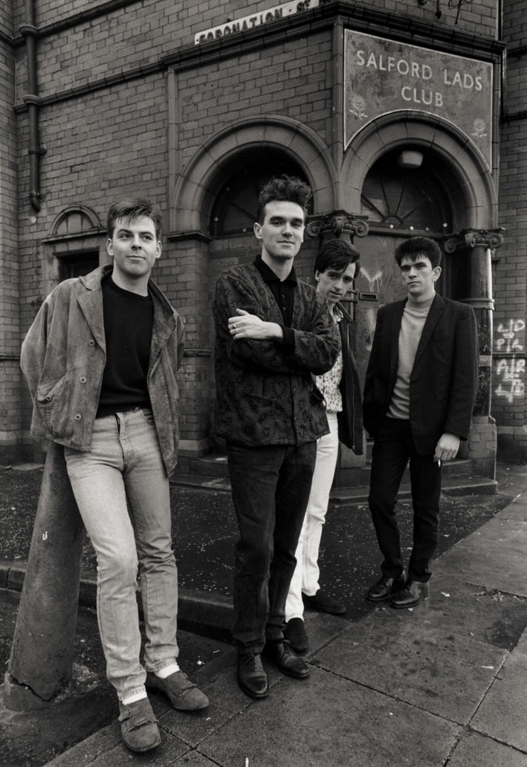

(Copyright wrightphoto.co.uk)

CHARITY PHOTOSHOOT FOR SMITHS FANS

Time 11am –1pm

Date Sunday 10th April 2005

At the SALFORD LADS CLUB , St Ignatius Walk SALFORD

Stephen Wright, the photographer of the SMITHS for the classic Queen is Dead sleeve will return to capture any Smiths fans at the Salford Lads club,
in the 20th year since the original image was shot.

In return for a £5 minimum donation to the SUE RYDER CARE , Nettlebed Hospice
anyone can have their photo taken at the doors of the Salford lads Club.
All proceeds will go to the charity.

Images can then be downloaded from the web a few days later.

The Sue Ryder Hospice were very kind to Stephen’s father ,
who passed his last days there at the end of 2004.

